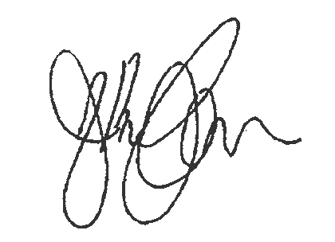
Our Safety Policy

At State Transport, safety is fundamental to the success of our business and part of our core values that underpin everything we do. We know this assists State Transport to be an industry leader and innovator in Transport and Warehousing.

We believe that:
- Safety is both an individual and team responsibility. We take personal accountability to take care of each other.
- All accidents and injuries are unacceptable, and we continually strive to eliminate hazards
- Having our leaders lead by example and demonstrate a visible commitment to health and safety to motivate, educate and support all personnel is critical
- Each of us must be dedicated to conducting all activities with the highest concern for the safety of our employees, partners, and communities

We are committed to:
- Embedding Safety in every aspect of our business whilst achieving compliance with all applicable Safety and Health legal obligations
- Continuously improving the Safety of our workplace by ensuring investment in our people capabilities, resources, and equipment
- Striving to create a Safety culture that inspires trust to achieve our goal – an accident free workplace.
The Safety Policy will be reviewed every two years or earlier if considered necessary to reflect changes in risk to our employee, partner, or community safety.

Albert Cenusa
Managing Director 29 March 2022

